**7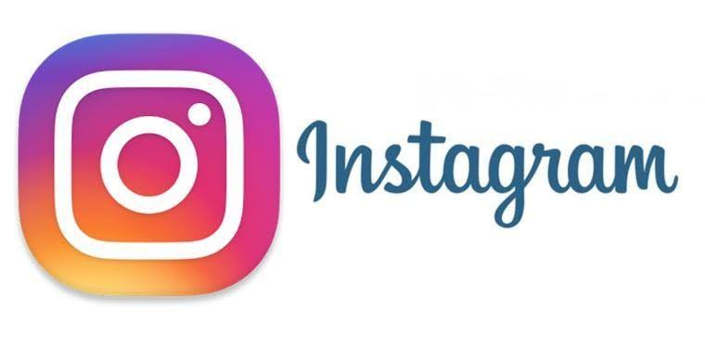 How to do advertisement on Instagram**

The goal of advertising is to reach people most likely to be willing to pay for a company's products or services and entice them to buy. Instagram is an American photo and video-sharing social networking service owned by Facebook, Inc. It was created by Kevin Systrom and Mike Krieger, and launched in October 2010 on iOS.  As of June 2018, Instagram has reached the 1 billion monthly active user mark. You can buy, run and track ads on Instagram in one of three ways. Within the App. The easiest way to run ads is by promoting posts you've shared on Instagram. Just select the post you want to promote, and then track how many people are seeing and interacting with your promoted post by tapping.

On average, Instagram advertising costs between $0.20 to $6.70, depending on the bidding model. For CPC or cost-per-click, advertisers pay $0.20 to $2 per click. For CPM, or cost-per-impressions, advertisers pay $6.70 per 1000 impressions. It's attracting tons of big brands because it's well worth it to advertise there. But even if you're not a multi-million dollar brand, Instagram ads are still just as important for you to use (if not more important. Ads look just like any other shared post on Instagram, which makes them feel less conspicuous. You can make Instagram video ads up to 60seconds long.

****But according to data from Wistia, the first 30 seconds of a social video is what matters most. If you can hook your audience in that timeframe, they're more likely to stick around and engage with your business. Instagram advertising is method of paying to post sponsored content on the Instagram platform to reach a larger and more targeted audience.



Once you've got those preliminaries taken care of, it's time to dive into creating your first Instagram ad.

1. Step 1: Choose your objective. To start, go to Ads Manager and click +Create.
2. Step 2: Identify your audience.
3. Step 3: Select your ad placements.
4. Step 4: Choose your budget and schedule.
5. Step 5: Create your ads.